Click ground floor router, go to Config, select Serial 2/0, set IP address as 11.0.0.2 and subnet mask as 255.0.0.0. Click 1st floor router, go to Config, select Serial 2/0, set IP address as 10.0.0.2 and subnet mask as 255.0.0.0.

Click interfloor router, go to Config, under Routing, Click Static. Add the routes of packet transmission from interfloor router to destination subnet.

Repeat the same for ground floor and 1st floor routers.

***To test the network:***

* Use the ping command in the command prompt to check for successful transmission between the two networks.
* If the IP address gets pinged in other system successfully then the network is working successfully.
* Or alternatively, the simulation of simple PDU, from source device to destination device, can also be checked.

**Simulation Output/Output:**

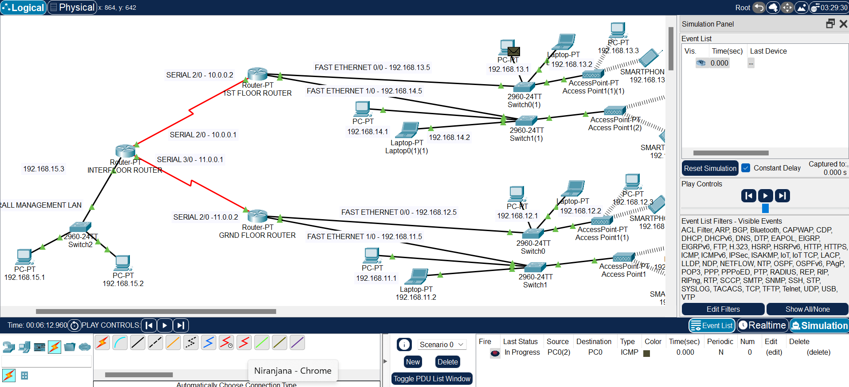

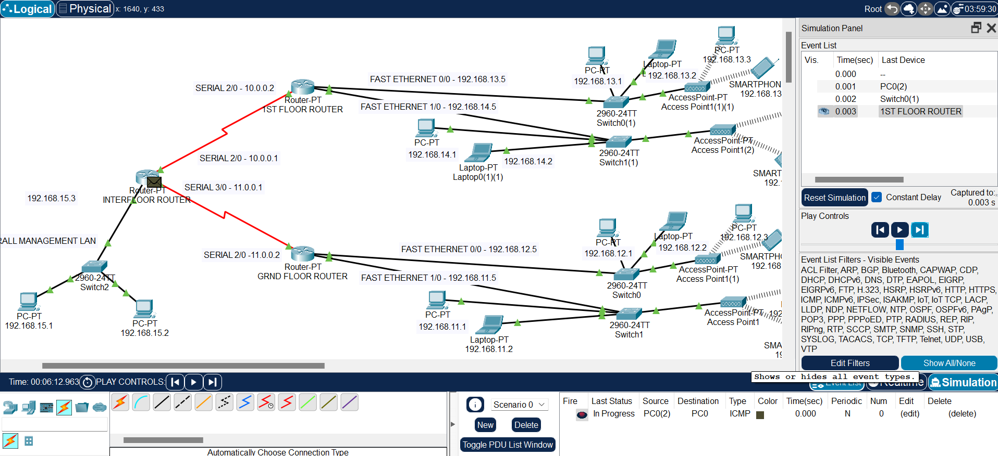

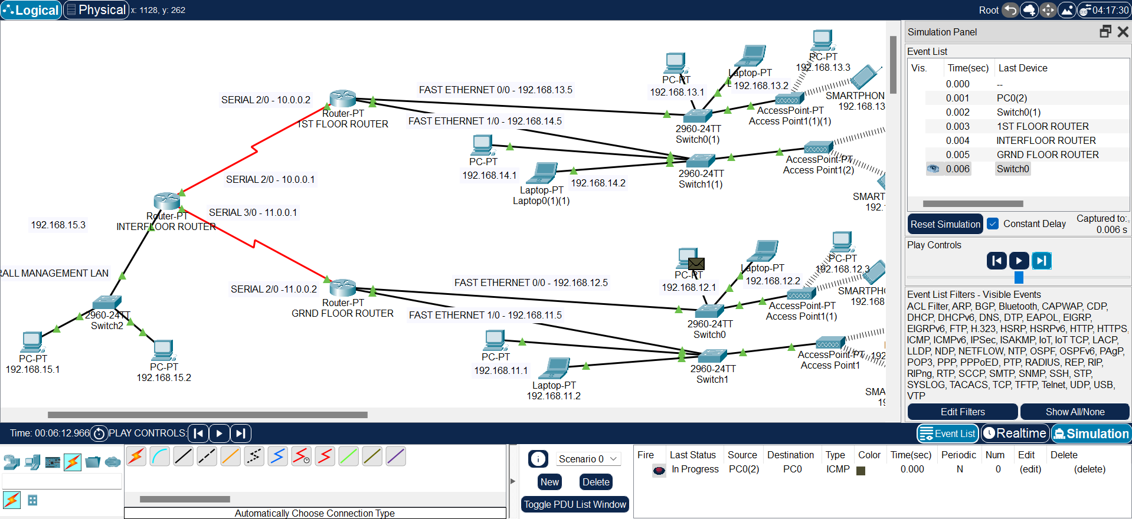

**Result:**

Thus, the hierarchical network architecture which provides a robust, scalable, and secure solution for a hypermarket with multiple floors and systems was designed and communication simulated successfully, on Cisco Packet tracer platform.